Student Learning Outcome Reporting Template
Annual Student Learning Outcome Report Fields
STUDENT LEARNING OUTCOME | EXPECTED OUTCOME | ASSESSMENT INSTRUMENT | RESULTS  STUDENT TYPE, NUMBER OF STUDENTS ASSESSED, NUMBER OF STUDENTS WHO SUCCESSFULLY MET OUTCOME | USE OF RESULTS / PLAN OF IMPROVEMENT
- Student learning outcomes state what students are expected to know or be able to do upon completion of a course or program. At both the course and program level, student learning outcomes should be clear, observable and measurable, and reflect what will be included in the course or program requirements (assignments, quiz, exams, projects, capstone activities etc.).  - The Student Learning Outcome should to be a well-written statement that clearly articulates what students will be able to demonstrate by the end of the course or program.  SLO Statement Resources & Tips:  Student Learning Outcomes Statement Resources. National Institute for Learning Outcomes Assessment. | - The expected outcome represents the threshold by which success is achieved.  - Example: “At least 85% of students who enroll in ACC 1202 will be able to successfully… ” | - Educational units should report how they will objectively measure the stated learning objective in the course.  - Example:  - Instructor John Smith gave a 50 question final examination to ACC 1202 students at the end of the term - 48 questions were multiple choice items relating to common principles of ACC and 2 questions directly related to mathematical problem solving. These two quantitative reasoning questions were scored by using a standardized mathematical problem solving rubric. In this particular example, listing ‘ACC 1202 exam’ as the assessment instrument would be inaccurate because only 2 of the 50 were evaluated for mathematical problem solving. The following would be a more appropriate entry:  ‘Two embedded quantitative reasoning questions were scored in the ACC_1202 final exam. Used the college mathematical problem solving rubric to consistently evaluate these embedded items.’ | - Educational units are responsible for reporting the total number of students assessed and the total number of students who successfully met the objective.  - Data for online courses and traditional courses will be reported on separate lines.  - Example:  - Traditional Course - Students Assessed: 314  - Traditional Course - Students Who Successfully Met Outcome: 274  - Online Course (s) - Students Assessed: 0  - Online Course(s) - Students Who Successfully Met Outcome: 0 | - The ‘use of results / plan of improvement’ section should show that the educational program is making an analysis of the data and using that data to improve/optimize student learning. Be mindful that this structured process is intended to drive year-to-year improvements within all educational programs. That being said, if one were to print five years’ worth of Student Learning Outcome Reports for a particular educational program, one would expect to see that this process has led to positive improvements in student learning outcomes.  - It is appropriate to reference the prior year Student Learning Outcome Report to offer a more fluid connection from year-to-year.  - Example: During the prior year, the ACC 1202 course SLO results did not meet the expected outcome for mathematical problem solving and we suggested at the end of the year to introduce a new hands on Activity X to improve student learning in mathematics. We previously were teaching mathematical problem solving skills through lecture format via a PowerPoint and then assigning a homework assignment. Activity X was implemented on the eight week of the ACC 1202 course and the data collected from this year indicate a positive finding. In the prior year 225 of 300 ACC 1202 students successfully demonstrated proficiency in this mathematical problem solving (75% success rate) but in this current year 274 of 314 ACC 1202 successfully demonstrated proficiency (87.2%) which represents a 12.2% increase.  - This section needs to be detailed and around a paragraph in length. Individuals who submit entries of ‘No Action Taken’, ‘Continue to Monitor’ or an inadequate one sentence response will be asked to resubmit their report.
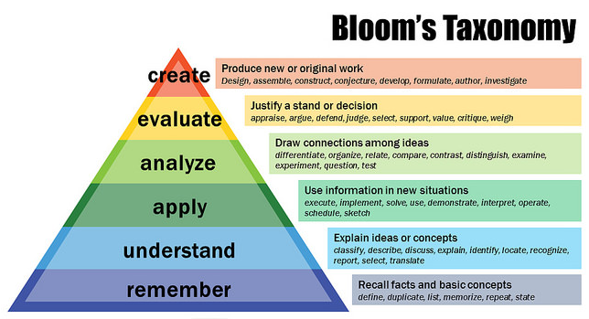

Student Learning Outcome Annual Report Template* * The template mirrors the official online Student Learning Outcome Submission Form and can be updated throughout the year.
GENERAL EDUCATION CORE STUDENT LEARNING OUTCOMES
All educational units are required to
STUDENT LEARNING OUTCOME OBJECTIVE | EXPECTED OUTCOME | ASSESSMENT INSTRUMENT | STUDENT TYPE | # OF STUDENTS ASSESSED | # OF STUDENTS WHO SUCCESSFULLY MET OBJECTIVE | USE OF RESULTS / PLAN OF IMPROVEMENT
WRITTEN COMMUNICATION (SLO #1)
 |  |  | Traditional Students
 |  |  | Online Students
CORE ORAL COMMUNICATION (SLO #2)
 |  |  | Traditional Students
 |  |  | Online Students
MATHEMATICAL PROBLEM SOLVING (SLO #3)
 |  |  | Traditional Students
 |  |  | Online Students
CORE CRITICAL THINKING (SLO #4)
 |  |  | Traditional Students
 |  |  | Online Students
CORE APPLICATION OF TECHNOLOGY (SLO #5)
 |  |  | Traditional Students
 |  |  | Online Students

PROGRAM-LEVEL STUDENT LEARNING OUTCOMES
STUDENT LEARNING OUTCOME OBJECTIVE | EXPECTED OUTCOME | ASSESSMENT INSTRUMENT | STUDENT TYPE | # OF STUDENTS ASSESSED | # OF STUDENTS WHO SUCCESSFULLY MET OBJECTIVE | USE OF RESULTS / PLAN OF IMPROVEMENT
PROGRAM-LEVEL STUDENT LEARNING OUTCOME (SLO #6)
 |  |  | Traditional Students
 |  |  | Online Students
PROGRAM-LEVEL STUDENT LEARNING OUTCOME (SLO #7)
 |  |  | Traditional Students
 |  |  | Online Students
PROGRAM-LEVEL STUDENT LEARNING OUTCOME (SLO #8)
 |  |  | Traditional Students
 |  |  | Online Students
PROGRAM-LEVEL STUDENT LEARNING OUTCOME (SLO #9)
 |  |  | Traditional Students
 |  |  | Online Students
PROGRAM-LEVEL STUDENT LEARNING OUTCOME (SLO #10)
 |  |  | Traditional Students
 |  |  | Online Students

