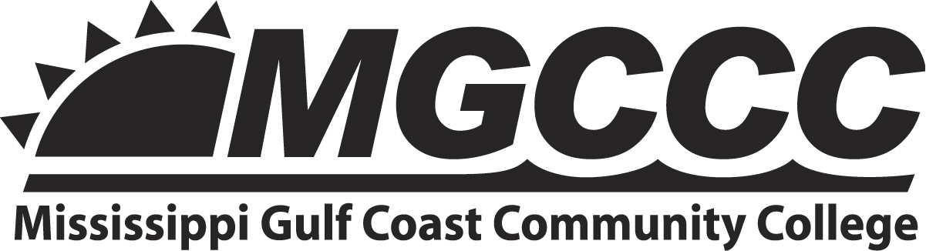
Federal Direct Loan Request Form
Summer 2022

Student’s Name: | Click or tap here to enter text.
Student’s ID #: | Click or tap here to enter text.
In order to be eligible for a Federal Direct Loan for Summer 2022, you must:
- Complete the 2021-2022 FAFSA.
- Be making Satisfactory Academic Progress (SAP) at the end of the Spring 2022 term.
- Submit official transcripts from all colleges attended.
- Enroll in a degree or certificate program.
- Register for a minimum of 6 credits in any combination of the summer terms and you must remain enrolled for 6 credits on the date of disbursement.
If you meet these requirements, please completely fill out the information below. Incomplete forms will not be considered.

Were you enrolled at MGCCC for Fall 2021? | ☐YES or ☐NO
Were you enrolled at MGCCC for Spring 2022? | ☐YES or ☐NO
Will you enroll at MGCCC for the Fall 2022? | ☐YES or ☐NO
How many hours will you take in Summer 2022? | Click or tap here to enter text.
List all colleges previously attended: | Click or tap here to enter text.
What is your graduation date from MGCCC? | Click or tap here to enter text. (Month/Year)
Loan amount requested for Summer 2022 | $Click or tap here to enter text.

- Students who received the maximum student loan award for Fall 2021 and Spring 2022 terms are not eligible for a Summer 2022 Direct Loan award.
- If you did not receive a student loan during the 2021-2022 academic year at MGCCC, you must complete the loan entrance counseling and MPN at www.studentloans.gov.
- Students who do not complete their summer courses may have their financial aid pro-rated and may owe MGCCC a balance.
- If a student did not attend MGCCC during the Spring 2022 semester and will not attend MGCCC during the Fall 2022 semester, then he/she is not eligible for Summer Financial Aid at MGCCC.
If it is determined that I am not eligible for financial aid, I understand that I am completely responsible for my educational expenses at MGCCC. I certify that all of the information on this form is true and complete to the best of my knowledge. I understand that if I purposely give false or misleading information as part of this request that I may lose my financial aid and be subject to a $20,000 fine, a prison sentence, or both.
Click or tap here to enter text. |  |  | Click or tap to enter a date.
Student Signature |  |  | Date

